Evaluation of tensile adhesion strength in mortar for coating with incorporation of crushing sand

Leandro Augusto Erba

Me. Professor, UNESP, Brazil

leandro.erba@unesp.br

Maximiliano dos Anjos Azambuja

PhD Professor, UNESP, Brazil

m.azambuja@unesp.br

ABSTRACT

The use of crushed sand, a by-product generated in quarries during the process of manufacturing crushed stone used in civil construction, can reduce the consumption of natural sand, reducing the environmental impact of the extraction of this material. In this sense, this research aims to evaluate the influence of replacing natural sand with crushed sand on the tensile bond strength of mortars. Mortars were made with crushed sand from quarries in the region of Bauru/SP, performing 3 percentages of substitution, in mass, of natural sand by crushed sand: 10%, 20% and 30%, plus a reference with 100% sand natural, totaling 4 strokes. All mortars were made in accordance with ABNT NBR 13276/2005. The performance of the mortars was evaluated through the tensile bond strength test, as recommended by the ABNT NBR 13528/2019 standard. In the end, it can be said that it is feasible to use crushed sand to replace natural sand in the percentage of up to 20% for making mortars for coating external walls, which showed the best adhesion results. It was also found that, for internal coating, it is possible to use up to 30% of crushed sand, without compromising the performance of the mortar.

KEYWORDS: Coating Mortar. Crushing Sand. Stone Dust.

1 INTRODUCTION

Contributing to the development of technology for the built environment in Brazil is fundamental for the improvement of architecture and urbanism projects in our country. Taking this as a starting point, this article is aligned with research published by the National Association of Technology in the Built Environment (ANTAC), which has a specific working group for analyzes focused on mortars, the GT Argamassas group (ANTAC, 2020) .
Aggregates used in civil construction are the most consumed mineral inputs worldwide. The construction industry uses about 50% of the mineral resources produced in the world, many of which are non-renewable. The products of these activities most used in civil construction are cement, lime and fine aggregates (sand) and coarse aggregates (gravel) (GUACELLI, 2010).
As aggregates are natural resources, their extraction is almost always far from the place of use and added to the fact that environmental inspection bodies are increasingly restrictive regarding the granting of new deposits, the final price of the aggregate tends to be increasingly high and its availability increasingly scarce (VALVERDE, 2001).
The extraction of natural sand is increasingly complex due to municipal and state laws, which follow the guidelines of Law no. 12,651, of 2012, which regulates the use and recovery of river beds and floodplains, in relation to available natural resources. Concern for the environment and the search for alternative materials reach all those who know that these reserves are scarce and some of them are not renewable. (TOKARSKI, 2017).
Restrictions on the extraction of natural sand do not, however, reduce the need for its use, since statistical surveys show a high sustained consumption of this aggregate in Brazil. The demand for alternatives that can replace them with efficiency and quality goes through the process of raising awareness of research and studies to find the right technical and economic alternative. (LA SERNA E REZENDE, 2009).
In Brazil, the growth of GDP (Gross Domestic Product) is directly related to the civil construction sector, which is the sector with the highest generation of jobs. The consumption of mineral resources in civil construction is directly linked to the growth in demand for goods and services and population growth, as shown in Figure 1 (BRASIL MINERAL, 2020).

Figure 1: Aggregate production compared to GDP
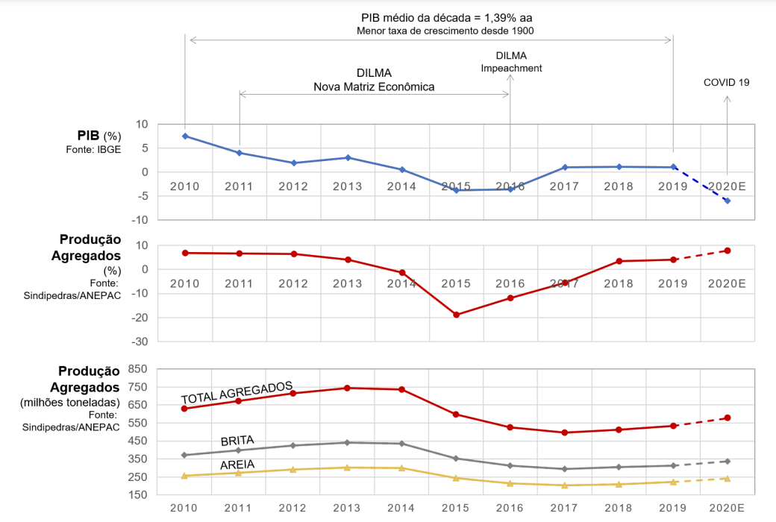
Source: Brasil Mineral (2020).

For Menossi et. al. (2010) there is a need to find a new alternative material to replace the river sand, as its extraction generates excessive erosion of the river causing environmental damage that must be avoided. Even so, according to the authors, many researchers find several materials that can replace river sand, one of the main materials being the by-products generated in the quarries, the so-called stone dust or crushed sand. Using different proportions of these materials; In combination with the river sand required in the mortar, good results in terms of use and durability can be obtained.
From an economic point of view, the lower cost of crushed sand in relation to river sand in regions where this product is scarce or far from supply centers is of great importance. From an environmental point of view, the fact that crushed sand came to complete the demand generated due to restrictions imposed on the extraction of sand from river beds can be mentioned. (PANDOLFO e MASUERO, 2005).
Sustainability must be present in all projects from their inception. For this, the use of new materials to replace the traditional ones has been a good alternative to minimize the impacts on the environment. As an alternative to the use of natural sand, the use of crushed sand appears. Research on the replacement of natural sand by crushed sand from basaltic rocks is incipient in Brazil, with a good potential for use in the manufacture of coating mortars.
One of the most important tests to evaluate the quality of the mortar is the tensile bond strength test. NBR 13528 (ABNT, 2019) defines adhesion as the property of the coating to resist normal and tangential stresses acting at the interface with the substrate, in addition to evaluating the interaction between the constituent layers of the coating system (base, base preparation and coating) . This standard proposes the test procedures for determining the tensile bond strength test.
According to Araújo (2014), adhesion is one of the most important properties in the analysis of mortar performance, which makes it possible to analyze its fixation to the substrate that was adhered. Thurler and Ferreira (1995) define adhesion as the bond of an atomic or molecular nature existing at the interface between a solid body and any other. Pereira (2012) states that this bond can be both physical obtained by the setting between the substrate and the adhesive, and chemical obtained through Van Der Walls electrostatic forces. Thus, Carasek (1996) clarifies that adherence is related to interactions resulting from chemical or physical-chemical phenomena.
NBR 13749 (ABNT, 2014) determines that mortar coatings for internal locations have a minimum bond strength of 0.20 MPa for internal walls and ceilings. For external sites, they must have a minimum bond strength of 0.30 MPa at 28 days of age.
Among the authors surveyed, who studied the incorporation of crushed sand in the mortar, we can see that only three authors performed the tensile bond test. This may be due to the fact that this type of assay requires several pieces of equipment, which are not always available to researchers.
In general, few authors have researched on the replacement of natural sand by crushed sand in mortars for coating walls and ceilings, this creates a research gap in the area, which corroborates to justify the importance of more research on this topic. Table 1 shows the results found by the authors in the tensile adhesion test.
Among the results found by the authors, we can note that Rosa (2013) and Tokarski (2017) observed gains in tensile adhesion as the percentage of crushed sand in the mortar increased. In general, this increase is noticed up to 30 or 40% of crushed sand, higher values tend to decrease the value of traction adhesion, when compared to the reference mix (100% of natural sand).
Diógenes (2016) obtained values close to 0.20 MPa (minimum value for internal coatings), this may be due to the fact that the author is the only one who was researching sands in the northeast region of Brazil, while Rosa (2013) and Tokarski (2017) worked with sands from the southern region of Brazil. And because they are natural resources, the sands tend to vary a lot in their characteristics, according to their geographical location.

Table 1: Results of adherence to traction found by the authors
Author(s) | Traces (%) | Traction adhesion (MPa)
Rosa (2013) | AB1,5 | 0,28
 | AB6 | 0,27
 | AB10 | 0,39
 | AB20 | 0,29
 | AB30 | 0,34
Diógenes¹ (2016) | AN100 | 0,21
 | AB25 | 0,16
 | AB50 | 0,14
 | AB75 | 0,21
 | AB100 | 0,19
Tokarski (2017) | AN100 | 0,55
 | AB20 | 0,73
 | AB40 | 0,72
 | AB60 | 0,58
 | AB80 | 0,65
Caption: AN: Natural Sand; AB: Crushing Sand
1: Results for Crushing Sand D
Source: Authors (2022).

2 OBJECTIVE

To evaluate the influence of replacing natural sand by crushed basalt rock sand on the tensile bond strength of coating mortars.

3 METHODOLOGY

3.1 Mortar preparation

For the manufacture of the mortars, the binders were used: cement CPII E-32, hydrated lime CH-III and plasticizer additive, in order to give greater workability and plasticity to the mortars produced. The aggregates used were: natural washed quartz sand from the Tietê River and extracted in the city of Pederneiras/SP (30 km away from Bauru/SP) and basaltic rock crushing sand (also called stone dust) collected at Pedreira Nova Fortaleza. , located in the city of Pederneiras/SP. The materials used are illustrated in Figure 2.

Figure 2: Materials used to manufacture the mortars
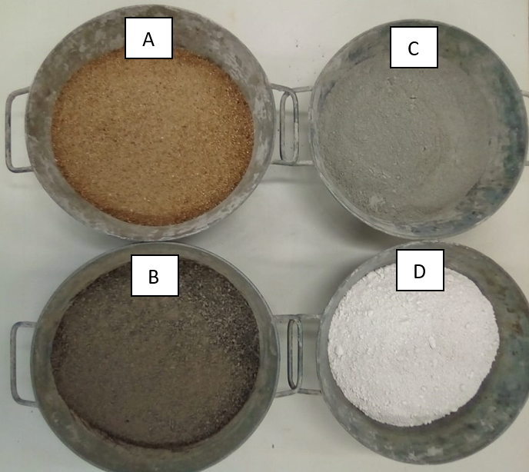
Caption: A) Natural Sand; B) Crushing Sand;
C) Cement CPII E-32; D) CH-III hydrated lime
Source: Authors (2022).

First, the aggregates were sieved in sieves with an opening of 2.8 mm in order to remove impurities and standardize the maximum diameter of the aggregates. In order to verify the granulometric composition, the granulometry test was carried out, according to NBR NM 248 (ABNT, 2003). The test was carried out on a sample (300g) of each aggregate used, with grains passing through a 2.8 mm sieve. Several compositions were made between natural sand and crushed sand, which are described in Table 1.

Table 1 - Composition of sands for granulometric study
Dash name | The amount  Natural Sand (%) | The amount  Crushing Sand (%)
AN 100 | 100 | 0
AB 10 | 90 | 10
AB 20 | 80 | 20
AB 30 | 70 | 30
Source: Authors (2022).

To define the trace, a dosing method for mortars with crushed sand created by Santos et.al. 2018. The proposed method corresponds to a set of sequential activities, illustrated in the flowchart in Figure 3, which allows obtaining a proportion of materials, developing experimental tests and defining the most appropriate trait (SANTOS et al. 2018).

Figure 3 - Flowchart of the dosage method
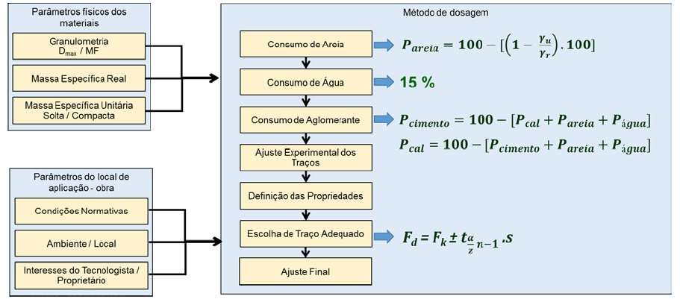
Source: SANTOS et al. (2018).

Based on the dosing method by Santos et al. (2018) it was possible to find the reference trace (Table 2), used to make all the sand mixtures proposed in this study.

Table 2 - Reference Trace
Unit | Cement | Lime | Sand | Water
(%) | 10,39 | 8,01 | 62,11 | 18,68
Volume (L) | 1,000 | 0,770 | 5,975 | 1,798
Mass (Kg) | 1,000 | 0,474 | 8,286 | 1,504
Source: Authors (2022).

The preparation of the mortars consisted of separating and weighing the materials, according to each trait, priming the concrete mixer and wheelbarrow used, mixing in a vertical axis concrete mixer (due to the predominance of this equipment on site). It started by placing only the aggregate with a portion of the water, for the condition of semi-saturation of the aggregate, as recommended by Buttler (2003), Miranda (2005) and Neno (2010). The detailed mixing steps are shown in the flowchart of Figure 4. The amount of material in each trace was sufficient to produce all the specimens without the need for a new mixture, avoiding variability of the results due to any type of change between the mortar production process.

Figure 4 - Flowchart of the mortar making process
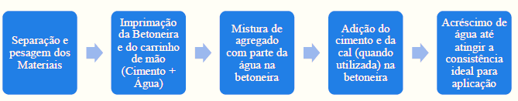
Source: Author (2022).

As substrate, 8-hole ceramic bricks (Bahia brick) were used, with a dimension of 19x19x9mm, the bricks were first roughcast with 1:3 mortar (cement: medium sand), with the addition of an adhesive additive for better adhesion of the roughcast to the substrate. . We waited three days for the roughcast to cure, and then apply the mortar.

3.2 Tensile adhesion strength test

The tensile adhesion strength was evaluated through the pull-off test, carried out in accordance with the procedures stipulated by NBR 13528 (ABNT, 2019), which determines the extraction of twelve samples of coating, chosen at random. The test was performed according to the following specifications.
1) The specimens were prepared in the laboratory in coatings applied on ceramic blocks, placed on the bench, kept at room temperature in the laboratory for 28 days;
2) Twelve specimens with a circular section, 50 mm in diameter, were removed for each trace;
3) The cut was made using a hole saw with a diamond edge and a depth of 20 mm;
4) The surface of the specimen on which the tablet (metallic, non-deformable with the test load, circular section, 50 mm in diameter, with a hole in the center for coupling the equipment) will be fixed on traction), was cleaned to remove disposable particles;
5) The traction equipment was coupled to the tablet and the application of the traction force was started, perpendicularly to the specimen, until it ruptured, noting the load value and the rupture form, verifying the most fragile area. of the coating;
6) The rupture stress was then determined by dividing the rupture stress (MPa) by the cross-sectional area of the specimen (mm²). The results depend on the form of rupture of the specimen, the stress found is equivalent to the tensile strength of the rupture section.
The results obtained were compared to the values of NBR 13749 (ABNT, 2013), which stipulates the minimum values for the coating (0.20 MPa for internal walls and 0.30 MPa for external walls). The experimental procedure is shown in Figure 5.

Figure 5 - Tensile adhesion strength test
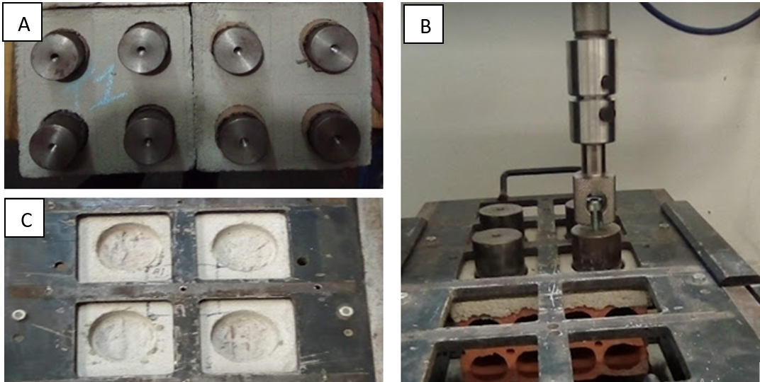
Legend: A) Pads glued to the CPs ; B) Carrying out the test; C) CPs after pullout
Source: Authors (2022).

NBR 13528 (ABNT, 2019) also classifies the types of possible ruptures that may occur in specimens of the tensile adhesion test, as shown in Figure 6.

Figure 6 - Types of ruptures of the specimen in the adhesion to traction

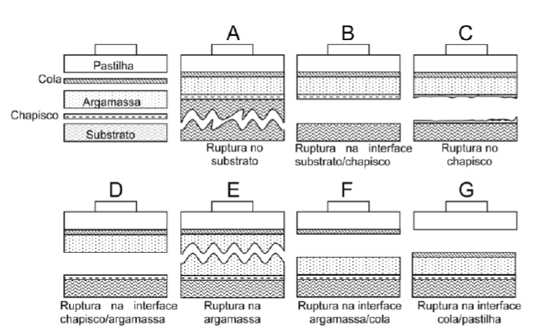
Source: NBR 13528 (ABNT, 2019).

4 RESULTS AND DISCUSSIONS

4.1 Grain size composition
The average granulometric curve of the aggregates is shown in Figure 7, where it can be seen that the aggregates are inserted in the area delimited by the usable zone, established in NBR 7211 (ABNT, 2009), which was used as a reference.

Figure 7 - Aggregate granulometric curves
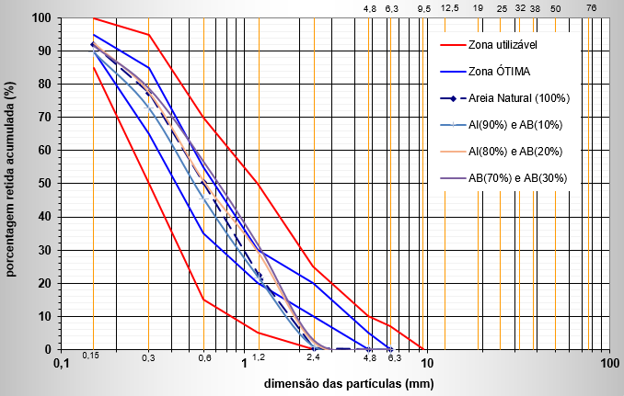
Source: Authors (2022).
Regarding granulometry, all traces meet the recommendations and are included in the lower and upper usable zones, especially traces AB10 (90% natural sand and 10% crushed sand) and AB20 (80% natural sand and 20 % of crushed sand), are in the range marked by the optimal upper and lower granulometry zones for fine aggregates, recommended by the standard.

4.1 Ensaio de aderência à tração

4.2 Tensile adhesion test

Tests were carried out to determine the tensile bond strength for all the proposed mortar traits at the age of 28 days. As determined by NBR 13258/2019, 12 specimens were used. The same NBR establishes a minimum value of tensile adhesion of 0.20MPa for internal coatings and 0.30MPa for external coatings.
The first tensile bond strength analysis was performed with the general average of the 12 specimens for each trait, showing AB 10 (0.44 MPa) and AB 20 (0.48 MPa) with values greater than AN 100 (0 .39 MPa). The AB 30 trace (0.25 MPa) was above the minimum value required for internal coatings. In Figure 8, the graph shows the results compared with the reference trace (red line) and with the minimum values required by NBR 13258/2019 for external coatings (green line) and internal coatings (blue line).
A good part of the researchers who studied mortar with crushed sand did not perform the tensile bond test, perhaps because it is a test with a high level of complexity in relation to other tests for mortar, however, among the researchers who performed this test it is possible to notice that the results found in this research were better than those found by Rosa (2013) and Diógenes (2016), indicated in Table 1.

Figure 8 - Tensile bond strength graph at 28 days

Source: Authors (2022).

Table 2 shows the result obtained with each CP (Special Body) analyzed, its resistance achieved, as well as the type of rupture. At the end, Table 2 also shows the mean, standard deviation and coefficient of variation of each trait studied.

Table 2 - Specimens and types of rupture
CP | AB10 | T.R. | AB20 | T.R. | AB30 | T.R. | AN100 | T.R.
 | MPa |  | MPa |  | MPa |  | MPa
1 | 0,47 | E | 0,55 | E | 0,19 | E/C | 0,34 | E/C
2 | 0,49 | E | 0,48 | E | 0,29 | E | 0,31 | E
3 | 0,48 | E | 0,36 | E/C | 0,27 | E | 0,38 | E/C
4 | 0,48 | E | 0,39 | E | 0,25 | E | 0,38 | E
5 | 0,47 | E | 0,48 | E/C | 0,28 | E | 0,45 | E
6 | 0,38 | C | 0,41 | E | 0,34 | E | 0,45 | E
7 | 0,46 | E | 0,47 | E | 0,24 | C | 0,32 | C/E
8 | 0,56 | E | 0,5 | E | 0,32 | E | 0,48 | E
9 | 0,43 | C/E | 0,43 | E/C | 0,28 | C/E | 0,44 | E
10 | 0,35 | C | 0,58 | E | 0,26 | C | 0,38 | E
11 | 0,36 | C | 0,61 | E | 0,25 | C | 0,33 | E/C
12 | 0,38 | E | 0,51 | E | 0,25 | E | 0,43 | E
Average | 0,44 |  | 0,48 |  | 0,27 |  | 0,39
SD | 0,06 |  | 0,08 |  | 0,04 |  | 0,06
CV(%) | 14,30 |  | 15,75 |  | 14,46 |  | 14,86
Subtitle:
CP: Body of Test; CV: Coefficient of variation; SD: Standard Deviation; TR: Type of Rupture
Source: Authors (2022).

5 FINAL CONSIDERATIONS

The present research sought to study the performance of mortars made with the incorporation of crushed sand from quarries located in the region of Bauru/SP. The results obtained reveal a satisfactory performance by the modified mortars and it is hoped, with this article, to have contributed to the deepening of the knowledge of the properties of mortars with the incorporation of fine crushing aggregates.
Currently, mortar with crushed sand, both for laying and for coating, is little used in the construction sector in the region of Bauru/SP, possibly due to the lack of knowledge of the performance of this material. However, basaltic rock reserves are abundant in the region of Bauru/SP, which makes it possible to use crushed sand to replace natural sand, reducing the impacts on the environment caused by its extraction in rivers and providing a destination that adds more value. to the by-product generated in the quarries.
It can be said that it is feasible to replace natural sand with crushed sand for the production of mortars, improving the performance of the coatings, up to the proportion of 20% crushed sand and 80% natural sand (Trace AB20) for external coatings and for internal coatings, the replacement can reach up to 30% of crushed sand (Trace AB30), without compromising the quality of the coating performed.
It can be said that it is feasible to replace natural sand with crushed sand for the production of mortars, improving the performance of the coatings, up to the proportion of 20% crushed sand and 80% natural sand (Trace AB20) for external coatings and for internal coatings, the replacement can reach up to 30% of crushed sand (Trace AB30), without compromising the quality of the coating performed.

ACKNOWLEDGMENT

The authors thank the Coordination for the Improvement of Higher Education Personnel (CAPES) and the Universidade Estadual Paulista “Júlio de Mesquita Filho” (UNESP – Campus de Bauru) for their support.

BIBLIOGRAPHIC REFERENCES

ABNT: BRAZILIAN ASSOCIATION OF TECHNICAL STANDARDS. NBR 7211 : Aggregates for concrete Specification. Rio de Janeiro, 2009.

BRAZILIAN ASSOCIATION OF TECHNICAL STANDARDS. NBR 13276 : mortar for laying and covering walls and ceilings - Determination of the consistency index. Rio de Janeiro, 2016.

BRAZILIAN ASSOCIATION OF TECHNICAL STANDARDS. NBR 16541 : mortar for laying and covering walls and ceilings – Preparation of the mixture for testing. Rio de Janeiro, 2016.

BRAZILIAN ASSOCIATION OF TECHNICAL STANDARDS. NBR 13281 : mortar for laying and covering walls and ceilings - Requirements. Rio de Janeiro, 2005d.

BRAZILIAN ASSOCIATION OF TECHNICAL STANDARDS. NBR 13528: Coating of walls and ceilings with inorganic mortars. Determination of tensile adhesion strength . Rio de Janeiro, 2019.

BRAZILIAN ASSOCIATION OF TECHNICAL STANDARDS. NBR NM 248: Aggregates - Determination of granulometric composition. Rio de Janeiro, 2003.

NATIONAL ASSOCIATION OF TECHNOLOGY IN THE BUILT ENVIRONMENT (ANTAC). Mortar Group. 2020. Available at: < https://www.antac.org.br/argamassa > Accessed on: 10 jan. 2020

ARAÚJO, NN de. Performance of coating mortars produced with recycled aggregates from construction and demolition waste from the greater Natal-RN. 2014. 129 f. Dissertation (Master in Civil Engineering) – Technology Center, Federal University of Rio Grande do Norte, Natal, 2014.

MINERAL BRAZIL. The new normal in the aggregates industry. Available at: https://www.brasilmineral.com.br/noticias/o-%E2%80%9Cnovo-normal%E2%80%9D-na-ind%C3%BAstria-de-agregados. Accessed on: 03/22/2021.

CANOVA, JA Replacement of cement by crushed fines in coating mortar. Science & Engineering , vol. 26, no. 2, p. 11–19, 9 Mar 2018.

CARASEK, H.; GIRARDI, ACC; ARAUJO, RC; ANGELIN, R.; CASCUDO, O. Study and evaluation of recycled aggregates from construction and demolition waste for laying and coating mortars. Revista Cerâmica , São Paulo, v.64, n.64, p. 288-300, 2018.

CARASEK, H.; ARAUJO, RC; CASCUDO, O.; ANGELIN, R. Sand parameters that influence the consistency and mass density of coating mortars. Materia Magazine , Rio de Janeiro, v.21, n.3, pp. 714 –732, 2016.

CINCOTTO, MA; SILVA, MAC; CASCUDO, HC Coating mortars: characteristics, properties and test methods . Technical Bulletin. São Paulo: Technological Research Institute, n. 68, 1995.

CINCOTTO, MA; QUARCIONI, VA; JOHN, VM Cal in Civil Construction. In: ISAIA, GC Civil Construction Materials and Principles of Materials Science and Engineering. São Paulo: IBRACON, 2007. v. 1. p. 693-725.

DIÓGENES, AG; Study of the behavior of coating mortars with crushed sand in the Metropolitan Region of Fortaleza . Dissertation (Master in Civil Engineering) – Postgraduate Program in Civil Engineering: Structures and Civil Construction, Federal University of Ceará, Fortaleza, 2016.

FALCÃO BAUER, LA Construction Materials. Volume 1.5 ed. Rio de Janeiro: LTC, 2008.

FREITAS, C. Coating mortars with fine crushing aggregates from the metropolitan region of Curitiba: properties in the fresh and hardened state. 2010. 135 f. Dissertation (Master in Civil Construction) – Polytechnic Center, Federal University of Paraná, Curitiba, 2010.

ISHIKAWA, PH; CAMARINI, G. Behavior of artificial sand, of granitic origin, in mortar for laying simple concrete blocks for masonry . in. SUFFIB – SEMINAR: Use of Crushing Fine Fraction, 2, 2005, São Paulo. Anais... São Paulo: ANTAC, 2005. P.47-62.

GOLDONI, AG; PANDOLFO, LM; GOMES, AP; FOLLE, D.; MARTINS, MS; PANDOLFO, A. Evaluation of a method based on image analysis to obtain shape parameters in crushed sand grains. Ibracon Structures and Materials Magazine , São Paulo, v. 8, no. 5, p. 584-590, Oct./2015.

GUACELLI, PAG Replacement of natural sand by crushed sand from basalt rocks for cladding mortars . 2010. 164 f. Dissertation (Master in Building Engineering and Sanitation) – Center for Technology and Urbanism, State University of Londrina, Londrina-PR, 2009.

HOQUE, T.; RASHID, MH; HASAN, MD. R.; MONDOL, EF Influence of stone dust as partially replacing material of cement and sand on some mechanical properties of kill _ Advanced structures and Geotechnical Engineering , v. 2, no. 2, p. 54-57, Apr. 2013

KAZMIERCZAK, C. de S.; ROSA, M.; ARNOLD, DCM Influence of the addition of crushed sand filer on the properties of coating mortars . Built Environment , Porto Alegre, v.16, n.2, p.7-19, abr./jun. 2016

LA SERNA, HA; REZENDE, MM Aggregates for Civil Construction . National Department of Mineral Production, 2009. Available at: < http://anepac.org.br/wp/wp-content/uploads/2011/07/DNPM2009.pdf >. Access on: 15 Oct. 2019

PANDOLFO, LM; MASUERO, AB Properties of coating mortars produced with natural sand and basalt sand. In: BRAZILIAN SYMPOSIUM ON MORTARS TECHNOLOGY, 6., 2005, Florianópolis and INTERNACIONAL SYMPOSIUM ON MORTARS TECHNOLOGY, 1., 2005, Florionópolis . Anais… Florionópolis : ANTAC, 2005. p. 53-58.

ROSA, M. Analysis of the effect of the microfine content on the properties of coating mortars using basaltic crushed sand . 2013. 110 f. Dissertation (Master in Civil Engineering) – Center for Exact and Technological Sciences, University of Vale do Rio dos Sinos, São Leopoldo-RS, 2013.

RATO, VNPM Influence of Morphological Microstructure on Mortar Behavior. 2006. 314 f. Thesis (Doctorate in Civil Engineering) – Faculty of Science and Technology, Universidade Nova de Lisboa, Lisbon, 2006.

SANTOS, WJ dos; ALVARENGA, R. de CS; SILVA, RC da; PETROTI, LG; SOUZA, AT; FREIRE, AS Analysis of the influence of the type of fine aggregate on the characteristics and dosage of mixed mortars. Built Environment , Porto Alegre, v. 19, no. 4, p. 271-288, Oct./Dec. 2019

SANTOS, WJ dos; ALVARENGA, R. de CSS; PEDROTI, LG; SILVA, RC da ; FREIRE, AS; MORAES, BA de; CARVALHO, CC Proposal for a dosage method for coating mortars with artificial crushed sand. Built Environment , Porto Alegre, v. 18, no. 1, p. 225-243, Jan./Mar. 2018

SILVA, Narciso Gonçalves Da. Coating mortar for cement, lime and crushed limestone sand. 2006. Available at: < https://acervodigital.ufpr.br/handle/1884/4660 >. Accessed on: 7 Apr 2021.

TOKARSKI, R. B.. Behavior of limestone crushing sand in cladding mortar . 2017. Universidade Tecnológica Federal do Paraná, 2017. Available at: < http://repositorio.utfpr.edu.br:8080/jspui/handle/1/2736 >. Accessed on: March 4, 2021.

TRISTÃO, FA Influence of the textural parameters of the sands on the properties of mixed coating mortars . 2005. 228 f. Thesis (Doctorate in Civil Engineering) – Technological Center, Federal University of Santa Catarina, Florianópolis, 2005.

MENOSSI, RT et al . Stone Dust: an alternative or a complement to the use of sand in the preparation of concrete mixtures. HOLOS Environment , v. 10, no. 2, p. 209-222, 2010.

VALVERDE, FM Aggregates for civil construction: Brazilian Mineral Balance, São Paulo: National Association of Entities Producing Aggregates for Construction, 2001.

