Popular commerce and the urban landscape

Pablo Corrêa Lima
Master’s Student, UFJF, Brazil
pablo.lima@estudante.ufjf.br

Frederico Braida
PhD Professor, UFJF, Brazil
frederico.braida@ufjf.br

SUMMARY

This article covers the theme of popular commerce related to the urban landscape of cities, highlighting the need to recognize this type of economy that is important in the dynamics of occupation and living in urban centers, for the generation of income for economically disadvantaged classes and the diversity of products and services. The objective of this research is to analyze how popular commerce can be identified and considered as an important element in the construction of the urban landscape by individuals. The methodology used was a literature review on popular commerce and its characteristics and on the definitions of an urban landscape, then analysis was carried out of how popular commerce can be inserted in the urban landscape and how it can change it, from the conflicts between urban agents. In the end, we can identify that popular commerce is still seen with some prejudice, as it is culturally associated with issues of informality, marginality, and “dirtiness” in urban centers. Generating the feeling that this type of commerce is not considered by many individuals in the imagery construction of urban landscapes.

KEYWORDS: Popular Commerce. Urban landscape. City image.

1 INTRODUCTION
Commerce is a fundamental activity in cities and is directly related to the emergence of large urban centers. Among its various types of exchange and variety of products and services, it has social and cultural characteristics. With the development of the capitalist system, different types of work, transformations in consumption, in the production of goods and services were provided (FERREIRA, 2019). Due to economic inequalities, some activities arise, often initiated informally, by individuals who try to market products in urban centers as a way of surviving unemployment, this universe was considered in this research as popular trade.
The urban landscape can be understood as the way an individual or a certain group defines the image of the city as a symbolic character (BONAMETTI, 2004). From different elements of the city, buildings, natural elements, cultural customs, climate, whether physical elements or not, we can consider that popular commerce and its diversity of activities contribute to or hinder the understanding of the urban landscape by the observer. This condition of acceptance or not of this modality of commerce in the urban landscape depends on several factors of experiences and particularities in the formation of the individual, such as cultural, economic, memory characteristics and daily experiences.
According to Maximiano (2004), the urban landscape is in constant transformation, as the population adds new symbols and disregards others. This existing dynamic allows the urban imaginary to be constantly under construction, at a given moment an element can be part of the urban landscape and be considered relevant by the majority of the population, at other times it can be forgotten, even if it is actively participating in the daily routine of cities. In some situations, this fact can occur with popular commerce, which is often overlooked by public authorities, part of the population and urban planners, despite its economic and spatial importance for the vitality of urban centers.
As the urban landscape is not understood only by the physical characteristics of the city, the disputes that occur between urban agents will also be considered by individuals in the process of building the city's image. Popular commerce presents territorial disputes with pedestrians and vehicles in relation to road occupation, and economic disputes with shopkeepers. Thus, generating the need for intermediation by the public power in an attempt to alleviate conflicts, without a certain group of urban agents being privileged or harmed, guaranteeing the organization and functioning of the dynamics of urban centers.
The objective of this article is to analyze how popular commerce can be identified and considered an integral part of the urban landscape in cities, since this modality of commerce presents unique characteristics that are very important for the economic development of workers from less favored economic classes, in addition to carrying out transformation in the dynamics of urban space, through social and cultural characteristics.
It is also possible to highlight the need for urban planning in an attempt to reorganize popular commerce in cities, since a thorough study of the demands, needs and characteristics of these popular traders, who are often working on the streets for the sustenance of their families, is not developed.

2 METHODOLOGY
To carry out this research, the literature review method was adopted, which was divided into three moments, (1) concepts and definitions of popular commerce; (2) urban landscape concepts and definitions; and (3) an analysis carried out by the authors of this article, on the relations of how popular commerce is inserted in the urban landscape and can change it, generating conflicts between the participating agents of the dynamics of the city.
3 POPULAR TRADE
In cities, popular commerce can be identified as a way of meeting some of the demands of the middle and lower-class population, offering modalities of consumption and services that work dynamically, providing relatively easy access to products, most of the time close to large urban centers, places of passage and agglomeration.
In addition to the search for lower-priced products, another factor that contributes to the growth of popular commerce is precisely its opposite, that is, the creation of shopping malls, commercial spaces in upscale neighborhoods far from the center, where their products will be sold at a higher price, with a tendency to exclude the coexistence of economic classes with higher purchasing power with the ones with lower purchasing power, creating socioeconomic segregations in the city (RIGATTI, 2003).
The term popular trade can be covered by several retail sectors, having different meanings in relation to the region or culture where it is inserted. According to Lenzi (2014), one of the main characteristics of popular commerce is the attempt to “fill” the eyes of customers with products of different brands, shapes and sizes, having a huge variety of options and different types of products, adding to a price well below that of traditional physical stores. As shown by Cleps (2009), another important factor is the location of this type of commerce, which is often concentrated close to points of a greater flow of people, such as train stations, subway stations, bus terminals and bus stations.

As it is an economic activity characteristic of the streets, the location of street commerce and services depends exclusively on the public space, such as public areas and roads. Among the forms of this activity carried out by street vendors, three types predominate: 1) mobile point (effective), with dismountable equipment (tents and small stalls) or motor vehicles; 2) in circulation, with pushcarts, trays and other supports that serve to expose their goods and 3) fixed point, that is, non-removable tents (KITAMURA; MIRANDA; RIBEIRO FILHO, 2007, p. 22).
As shown above, there are strategies for the appropriation of urban space by popular traders, which, in addition to their physical location (close to transport facilities) and their strategies for varied low-priced products, influence the routine activities of the city, reinforcing the character of competitiveness and competition, either with other popular merchants or shopkeepers.
Popular commerce can be classified in different ways, according to the opinion of authors or understanding of the population in which the modality is inserted. To carry out this research, we adopted the term popular trade to define commercial activities such as street vendors (Figure 1), stalls mounted by crates, carts, tents, tents for selling food (Figure 2), and improvisation of stalls on the sidewalks for displaying products to be marketed.

Figure 1 – Popular Commerce Types: Street vendor (tents)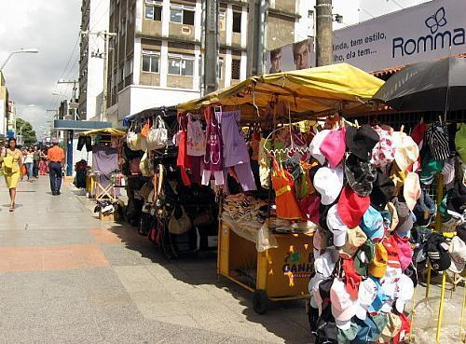
Available at: https://dicasdoconsumidorblog.files.wordpress.com/2016/07/ca2bd8ed0c584917a69800e2f7e0ced3_camelospraa007.jpg. Accessed on: Oct. 5th, 2022.
Figure 2 – Types of Popular Trade: Pushcart street vendor (food)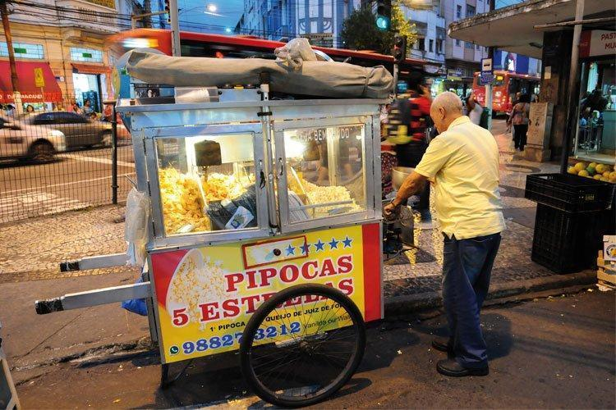
Available at: https://tribunademinas.com.br/wp-content/uploads/2018/05/2.-Pipoca-Cinco-Estrelas.jpg. Accessed on: Oct. 5th, 2022.
According to a study carried out by Kitamura, Miranda and Ribeiro Filho (2007), when identifying the products most commonly found in the retail sector of popular commerce in urban centers in Brazil, the following products were highlighted: food, beverages, cigarettes, footwear, clothing, accessories (jewelry, umbrellas, belts, buckles), toys, watches, bed and bath products, hygiene products, school material, crafts, cosmetics and perfumes. As for the services practiced by popular commerce, the following were highlighted: shoe shiners, car washers, car guards, stands of “jogo do bicho” (a Brazilian illegal and very popular lottery of numbers associated to animals), locksmiths, general repairs, photographers and “advertisers” (sandwich-man), such as those who wear a uniform with the words: “I buy gold” (KITAMURA; MIRANDA; RIBEIRO FILHO, 2007).
Another aspect that is often associated with popular commerce is the issue of informality. This type of trade can often refer to illegality, piracy and smuggling, generating bad impressions from certain individuals in society, when referring to popular trade (MOREIRA, 2007; GOULART, 2008). If we look at it from this point of view, the discussions are distinct and, not rarely, contradictory. Based on this, this research does not aim to deepen the terms of informal/formal and legal/illegal trade and considers popular trade as a whole, a large group, as the central object of the study. Finally, this issue is quite complex, as it encompasses inspection issues by regulatory agencies, specific legislation by municipalities and cultural characteristics of the societies in which they are inserted.

4 URBAN LANDSCAPE
In previous periods, the landscape was associated only with natural elements, such as vegetation, forests, mountainous terrain, oceans and forests. According to Maximiano (2004), in antiquity, the concept of landscape was restricted only to the internal gardens of palaces, a characteristic very similar to the Renaissance, but with the difference of the large production of paintings that represented elements of nature, such as horizons, for example, based on representation using the technique of perspective, developed at the time. The concept of the urban landscape appears after the great densification of city centers that occurred during the Industrial Revolution, adding industrialized elements built by human beings and not just elements of nature (MAXIMIANO, 2004).
In addition to the physical aspects of cities, whether natural or man-made, in the postmodern period (approximately between 1970 and 1990), some immaterial criteria were adopted for the concepts of the urban landscape:

Urban landscapes should not be read only through what we see, but also through what we identify with; through what we cannot see but feel; in short, through everything that helps us to have sensations or, still, through everything that makes vision possible, which makes us see more than we could see. When arriving in a city, the first impressions one has of the buildings, the squares, the vegetation, even the light, the sounds and even the air, in which the dust of its streets hangs, are indications to obtain a true picture of the places (BONAMETTI, 2004, p. 108-109).
Cultural, social and economic characteristics become part of the urban landscape, since the urban landscape is not identified from a static analysis of the city, but rather from an experience in constant movement, often generated by the actions of human beings when intervening in physical spaces. Therefore, Bonametti (2004) considers that the urban landscape can be perceived from the relationship between man and nature, this landscape is given by the attempt to organize the space by the human being, based on a natural environment, it can be understood as an individual or collective landscape, since the landscape is formed from an individual's perception of the context in which he is inserted.
It is evident, in contemporary times, the need to observe immaterial characteristics of the city to identify an urban landscape, adding to the experience of the physical space by the observer. As experiences change over time, urban landscapes can also undergo changes, sometimes excluding previously established symbols to make way for new urban dynamics:

(...), the landscape can be understood as the product of interactions between elements of natural and human origin, in a given space. These landscape elements are dynamically organized over time and space. This results in features and conditions that are also dynamic, differentiated or repeated, which allows a classification, by grouping similar arrangements, separating them from the different ones (MAXIMIANO, 2004, p. 90).
Referring to the user's perceptions, the urban landscape can be understood from the four senses of the human body: vision, smell, touch, and hearing. There are several methods for identifying and classifying urban landscapes, which are related to the experiences of the individual who is performing the landscape analysis. Vision is often the main sense for analyzing the urban landscape. Cullen (2010) develops a method for identification in the urban landscape, through his research, focusing on visuality. The author characterizes three factors for a visual perception of the city: (i) optics: serial vision from the individual's walk around the city, several memorable clippings are created; (ii) location: related to the individual's sense of location; (iii) content: perceptions of colors, textures, shapes that the individual selects and memorizes when walking around the city (CULLEN, 2010, p. 11-13).
Another important author on perceptions of the urban landscape is Lynch (2006), who considers that the image of the city must be identified in parts, making it impossible to analyze it as a whole. Based on this assumption, the author develops five elements that he considers fundamental for reading the city and understanding the urban landscape: (i) paths: city streets with specific characteristics and elements; (ii) limits: which can be elements of connection or segregation of the city (bridges, rivers, viaducts); (iii) neighborhoods: parts of the city that have similar characteristics and are located geographically close to each other; (iv) nodal points: places that direct the flow of people or vehicles, such as intersections; (v) landmarks: these are elements that the observer does not enter, but stand out in the landscape, as they present different shapes and scales compared to the whole (LYNCH, 2006, p. 57-84). These elements do not work separately, but depend on the identification and articulations between them by the observer.
Based on the researched authors, to carry out this research, the definition of urban landscape was understood as a set of relationships between human beings and the environment, whether natural or built, enabling the identification of its cultural, social and economic aspects based on the transformations that took place in the urban landscape of cities.
The way in which each person appropriates the urban space leaves marks, which are perceived through the urban landscape, and can be instantaneous, just for a quick moment, can remain for a period or can last for a longer period of time. The urban landscape occurs as the action takes place in the space-time relationship (SILVA, 2020, p. 59).

5 RELATIONS OF POPULAR TRADE WITH THE URBAN LANDSCAPE
The landscape of cities is made up of various physical or symbolic elements, among which we can highlight buildings, land sites, green areas, urban furniture, population habits, cuisine and forms of commerce in general. In addition to these elements, the circulation of people and vehicles, advertisements and sounds are landmarks that help in the legibility of the urban space (SILVA, 2020).
Regarding popular commerce, merchants play a role in building the city's image. The way they occupy the streets with their stalls and pushcarts, which have colors, textures and coverings that distinguish them from the built mass of buildings, allows them to also be considered agents that participate in and change the urban space (CABRAL, 2018).
According to Moreira (2007), the presence of popular commerce in cities causes conflicts between the agents involved, the government that intends to regulate and organize the city, shopkeepers who complain about commercial competition with street vendors, pedestrians and vehicles that compete for space in the streets. This scenario of disputes can be easily identified in the urban landscape of large urban centers.
We can identify commercial modalities are part of the construction of the urban landscape, mainly with capitalist practices, often allowing the coexistence of commercial models for audiences of different classes in the same urban space, generating disputes.

The urban landscape is a liquid substrate, ephemeral and instantaneous, captured, perceived and registered, the result of the sum of what is fixed and what is mobile, a result of the social relations established in the urban space, presenting the unequal process of capital reproduction, the conflicts, struggles, life, order and chaos, the beauty of the city and what may not be considered beautiful. (SILVA, 2020, p. 57).
As a result of conflicts between urban space agents and sociocultural characteristics, there are some prejudices by a certain portion of the population, which sees popular commerce as a degrading factor for the urban landscape. About popular trade:

Although their work is commonly accepted by the majority of the population and even by traders, the latent impression is that these workers “dirty” the city space they occupy, generating an ambiguous and permeable border of a region that occupies a kind of “purgatory or social limbo”, the target of several removal actions disguised as attempts of “urban improvement” and to attract consumers from other social strata who normally avoid the area, seen as a region where marginality and an unwelcome social heterogeneity prevail (JULIÃO, 2005, p 3).
In certain situations, the government adheres to this “hygienist” discourse, disregarding the presence of this commercial modality in cities, publishing legislation that does not support them, removing and prohibiting popular street vendors from operating in the streets, carrying out urban interventions without the direct participation of the urban agents affected in decision-making, often aiming at the aesthetic appeal from an attempt to reorganize the urban landscape. As happened in the city of Belo Horizonte, Minas Gerais, where the government transferred street vendors to popular shopping malls, in an attempt to reorganize the city, but it was not completely successful; after a certain period, new street vendors returned to the streets, increasing conflicts (SILVA; SLEUMER; RIVA, 2019).
Popular commerce cannot be considered only as a negative aspect in cities, since it facilitates the movement of goods, generates working conditions, the possibility of quickly acquiring goods, which in most situations are food or objects of routine use, that do not require a certain complexity of exhibitions for sale and storage. According to Ferreira (2019), the relationships generated by globalization, consumption and capital production added to the precariousness of work as a result of neoliberalism, created difficulties in survival and livelihood for certain workers, who seek in the informality of commerce a form of income due to unemployment, occupying and generating dynamics in public spaces.
From the thought and recognition of the importance of this modality of commerce, some movements of recognition of popular traders in the urban landscape emerged. In some cities, the government has carried out interventions on the roads, or even prohibiting the transit of vehicles to improve public spaces, allowing the establishment of popular trade points and their regularization. One can identify a certain recognition of the importance of this trade for the city, which often provides a better vitality on the streets, mainly in the streets of areas where the night period has little flow of people due to the closure of the stores at the end of the day.
An example of an attempt to organize the urban landscape considering and recognizing the existence of popular commerce occurred in the city of Rio de Janeiro. As stated on Portal de Notícias da Câmara Municipal do Rio de Janeiro (2021), the City Hall carried out a mapping of popular traders and regularized 179 street vendors that operated in the Bonsucesso neighborhood, issuing licenses to occupy streets and squares in the neighborhood, at pre-established areas, delivering uniforms and a standardized tent made of a metallic structure and finished in yellow (Figure 4). This project was called “Ambulante em Harmonia” (“Street Vendors in Harmony”) and is part of the “Rio em Harmonia” program, which aims to intervene in street vendors in other neighborhoods in the future. Street vendors were prohibited from selling the same products that are sold in physical stores on the streets where they are located, further evidencing the existence of conflicts.

Figure 3 – Standardized street vendors in Rio de Janeiro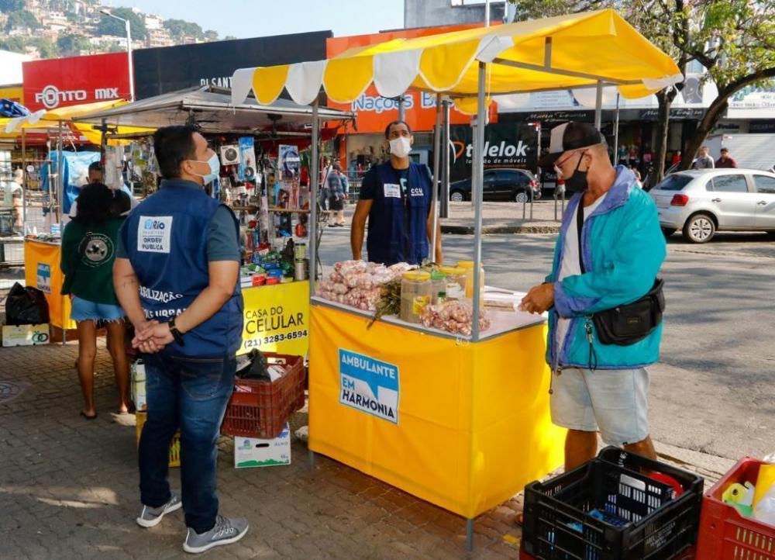
Available at: http://www.camara.rio/media/k2/items/cache/793ea701476d5db2a4fd8cf1e0bf5880_L.jpg. Accessed on: Oct. 5th, 2022.
Thus, it appears that popular commerce has remarkable characteristics in the urban landscape. It is evident that popular commerce influences spatial dynamics, the ways in which individuals perceive space, generating visual impacts, and may contribute to building a positive or negative image of cities, according to the social, cultural and economic characteristics of the observer.
As it can be observed, especially in relation to the examples presented in this article, the subject of popular commerce is complex and requires that it be treated in a holistic way, without prejudice, since, after all, it is an integral part of the landscape of cities.

6 FINAL CONSIDERATIONS
The urban landscape is composed of a diversity of elements that need to be analyzed and experienced by the observer. The presence of physical elements with a well-defined shape, simple textures and neutral colors tends to be easier and faster understood by the observer. In addition to visual aspects, cultural and economic formations will also influence the construction of the urban landscape; these factors tend to be one of the reasons for the population's denial that popular commerce is not part of the city's imagery, as a result of the urban landscape.
However, from a less hygienist and more pluralist perspective, popular commerce should not be seen as an impediment to understanding the urban landscape, since it transforms the dynamics of street use, allowing commercial, cultural and social exchanges. Popular commerce attracts a lot of people, serves consumers from economically less favored classes, makes it possible to experience the city at night and on holidays, generating income for people who were previously unemployed and excluded from the formal job market.
It is evident that there are prejudice and misconceptions against accepting this type of trade, which is often associated with illegality, marginality and “dirtiness” of urban centers; often, these characterizations come from public power managers themselves, who emphasize the need to remove street vendors from central regions in order to “improve” the organization of the city's image. These ideas can be considered hygienist, if we analyze the proposals for the removal of popular traders from the streets by managers, just for aesthetic appeal, not deepening the economic and social importance that this modality has.
We can see some attempts by the government to recognize popular commerce, whether by mapping street vendors, regulating illegal traders, standardizing stalls or demarcating their points. On the other hand, the standardization of tents, whether of the same color or material, will cause other effects on the urban landscape, perhaps improving the visual perception of the elements by the population, but excluding previously existing cultural and dynamic (spontaneous) characteristics.
It is evident that the urban landscape is in constant transformation, whether due to its physical, cultural, economic or social characteristics, at the same time that the perception of observers is also changing in the process of identifying symbols for building the image of the city. Furthermore, the urban landscape is also an instrument of power and control; hence its complexity.
The recognition of popular commerce as part of the urban landscape varies from observer to observer, but it is evident that currently there are greater recurrences of discourses to accept the importance of popular commerce in the functioning of cities. Therefore, we hope that this article can contribute to encourage thinking about the role of popular commerce in cities and open new paths for further research and discussions on the participation of popular commerce in the urban landscape.

7 BIBLIOGRAPHICAL REFERENCES

BONAMETTI, João Henrique. Paisagem urbana bases conceituais e históricas. Revista Terra & Cultura: Cadernos de Ensino e Pesquisa, [s.l.], v. 20, n.38, p. 107-123, 2004. Available at: http://periodicos.unifil.br/index.php/Revistateste/article/view/1332. Accessed on: Oct. 2nd, 2022.

CABRAL, Márcio Pereira. Território urbano em disputa: as transformações no centro de Porto Alegre como resultado de disputa de múltiplos agentes urbanos no período de 2005 a 2017. 2018, 110 p. Dissertation (Master in Geography) – Universidade Federal do Rio Grande do Sul. Rio Grande do Sul, 2018.
CLEPS, Geisa Deise Gumiero. Comércio informal e produção do espaço urbano em Uberlândia (MG). Sociedade e Natureza, Uberlândia, v. 21, p. 327-339, 2009. Available at: https://www.scielo.br/j/sn/a/mZzsqs6TBDHcTKmnd44pYmQ/?lang=pt. Accessed on: Sep. 28th, 2022.

CULLEN, Gordon. A paisagem urbana. São Paulo, Lisboa, Edições 70, 2010.

FERREIRA, Daniel Nunes. Território e territorialidades do comércio popular no bairro do Alecrim-Natal/RN. 2019, 110 p. Dissertation (Master in Geography) – Universidade Federal de Pernambuco, 2019.

GOULARTE, Cláudia Cardoso. Cotidiano, identidade e memória: narrativas de camelôs em Pelotas (RS). 2008, 116 p. Dissertation (Master in Social Sciences) – Universidade Federal de Pelotas. Rio Grande do Sul, 2008.

KITAMURA, Camila Kazumi; MIRANDA, Mariana; RIBEIRO FILHO, Vitor. O comércio e serviços ambulantes: uma discussão. Caminhos de Geografia, UFU, Uberlândia, v. 8, n. 23, p. 20-26, 2007. Available at: https://seer.ufu.br/index.php/caminhosdegeografia/article/view/15656/8855. Accessed on: Sep. 30th, 2022.

JULIÃO, Fábio Costa. Comércio popular e comércio de rua: uma etnografia das fronteiras entre o formal e o informal. In: COLÓQUIO INTERNACIONAL SOBRE COMÉRCIO E CIDADE: UMA RELAÇÃO DE ORIGEM, 1. Anais [...], 2005. Available at: http://www.labcom.fau.usp.br/wp-content/uploads/2015/05/1_cincci/011.pdf. Accessed on: Oct. 2nd, 2022.

LYNCH, Kevin. A imagem da cidade. São Paulo, Martin Fontes, 2006.
LENZI, Fernando César. Atratividade do comércio popular: fatores que motivam os clientes a comprar no comércio popular. Revista FAE, Curitiba, v. 17, n. 1, p. 144-161, 2014. Available at: https://revistafae.fae.edu/revistafae/article/view/11. Accessed on: Sep. 28th, 2022.

MAXIMIANO, Liz Abad. Considerações sobre o conceito de paisagem. RAEGA - O Espaço Geográfico em Análise, [s.l.], v. 8, p. 83-91, 2004. Available at: https://revistas.ufpr.br/raega/article/view/3391. Accessed on: Oct. 2nd, 2022.

MOREIRA, Angela. Mercados populares ou camelódromos: nascimento e variações de um objeto arquitetônico. In: COLÓQUIO INTERNACIONAL SOBRE COMÉRCIO E CIDADE: UMA RELAÇÃO DE ORIGEM, 2. Anais [...]. São Paulo, p. 1-8, 2007. Available at: http://www.labcom.fau.usp.br/wp-content/uploads/2015/05/2_cincci/4002%20Moreira.pdf. Accessed on: Sep. 29th, 2022.

PORTAL DE NOTÍCIAS CÂMARA MUNICIPAL DO RIO DE JANEIRO. Projeto Ambulante Harmonia é apresentado em reunião de Comissão Especial da Câmara Rio. Rio de Janeiro, 2021. Disponível em: http://www.camara.rio/comunicacao/noticias/665-projeto-ambulante-harmonia-e-apresentado-em-reuniao-de-comissao-especial-da-camara-rio. Accessed on: Oct. 2th, 2022.

RIGATTI, Décio. Camelôs, flanelinhas e os outros: privatização de espaços públicos. Paisagem e Ambiente, USP, São Paulo, v. 17, p. 41-67, 2003. Available at: https://www.revistas.usp.br/paam/article/view/40203. Accessed on: Sep. 28th, 2022.

SILVA, Camila Borges da. Paisagens ambulantes: as apropriações efêmeras na região da 44 em Goiânia. 2020, 191 p. Dissertation (Master in Projects and Cities) – Universidade Federal Goiás. Goiânia, 2020.

SILVA, Rafael César Costa; SLEUMER, Thiago Fantini Fernandes; RIVA, Giuseppe. Os camelôs de Belo Horizonte/MG na perspectiva da territorialidade urbana. In: SIMPÓSIO NACIONAL DE GEOGRAFIA URBANA, 16. Anais [...]. Universidade Federal do Espírito Santo, [s.l.], v.1, 2019. Available at: https://periodicos.ufes.br/simpurb2019/article/view/26568. Accessed on: Oct. 5th, 2022.

