**Small Cities and the Theory of Growth Poles: A New Perspective**

**Vitória Alves dos Santos**

Bachelor’s Degree in Architecture and Urbanism, Federal University of Goiás, Brazil

Master's student in the Project and City Graduate Program, UFG, Brazil

vitoria.alves@discente.ufg.br

**Wagner de Souza Rezende**

PhD in Architecture and Urbanism, Mackenzie Presbyterian University, Brazil

Permanent Professor of the Graduate Program Project and City, UFG, Brazil

wagnerrezende@ufg.br

**ABSTRACT**

This paper intends to reinterpret the Theory of Growth Poles, or Polarization Theory, formulated by François Perroux in the 1950s, to analyze the urban development of small cities. The theory suggests that the formation of urban centralities occurs heterogeneously at specific points in the territory, whose growth vectors are influenced by the actions of global socio-economic networks in local political arenas. These cities act as force fields that attract and stimulate growth in surrounding regions. This study aims to identify and analyze the effects of growth poles on the urban condition of small cities in the state of Goiás, Brazil, using criteria adapted from Perroux (1981) and reinterpreted for application in the context of cities located in southern Goiás. This is a theoretical work that, through a bibliographical review, presents a critical re-reading of the urban networks formed by city-regions, which we believe is relevant to the discussion on urban and regional planning in Brazil. The results of mapping the growth poles in the state of Goiás show social, cultural, political, and economic asymmetries in the territorial configurations. They reveal significant heterogeneity, indicating the need to redefine the criteria for their definition. This article aims to contribute to urban studies by identifying new agents influencing the territory, considering specific social, geographical, and economic contexts. The intention is to contribute to urban studies by listing new main agents influencing the territory, considering their contexts.

**KEYWORDS**:City-region. Urban Networks. Growth Poles.

1 INTRODUCTION: FROM THE THEORY OF GROWTH POLES TO CITY-REGIONS

The cities, on a regional geographical scale, operate within a reticular and territorial system of political and economic influences, made up of groups of small cities associated with medium-sized (mediating) cities or regional metropolises which, according to Perroux (1961), function as polarizing centers, geographical units that exert an influence on local development in each region, with effects on its urban configuration. In this sense, we will describe, identify, and discuss the concepts of “city-region” and “small cities”, in the light of the Theory of Growth Poles, in the context of the cities of Goiás.

The Theory of Growth Poles, developed by French economist François Perroux in the 1950s, shows that growth occurs at specific, non-simultaneous points in the territory, which develop through the action of a main agent, which generates direct influences on the surrounding space. This configuration acts as a force field that attracts surrounding regions, further contributing to the growth of the hub. The main agent, as the author calls it, although referred to in his work as a “key industry”, can have numerous personifications. Originally developed in 1955, the theory of growth poles was historically inserted in a process of seeking modernization, with the favoring of the industry as a symbol of progress. Thus, Perroux (1981) uses the term key industry as the only main agent polarizing the territory. Nowadays, it is possible to see that polarization is not only constituted by industrial action, since people move for various other reasons to neighboring cities, in a commuter movement, or just casually.

Richardson (1975) questions whether the growth pole is, in fact, a concrete spatial entity, observable by regional economic structures or, on the contrary, refers to a complex socio-spatial formation, an urban centrality, in which growth would be the result of a broader socio-political process, generating incentives for economic development on a local scale. Similarly, Lasuén (1976) states that the theory of growth poles describes the functioning of a verifiable socio-spatial dynamic but does not explain the necessary preconditions for the emergence of polarized centers or their effects on the city-region and interdependent territories. Both criticisms reveal an operational inconsistency in explaining regional economic development since it focuses more on observable results than on the causes and processes of the formation of growth poles. Thus, the theory of growth poles is considered limited and gives rise to the understanding that both cases listed by Richardson (1975) could be constituted in political and economic polarization, if they function as a system of local and regional flows in the context of the hierarchical influence of the city-region over small towns.

Considering the role of growth poles in the formation and transformation of urban and geographical territory between cities, we tried to list the growth poles in Goiás today. The large composition of small towns and their effects on territorialization processes, as described by Haesbaert (2002), demonstrate the extent to which polarization strategies allow us to think about urban development in small towns. The criteria used to select the growth poles were not the same as those argued by Perroux (1981), who defended the existence of a “key industry” to polarize a given region, but rather the main agents defined for this research, following a (re)interpretation of the theory of polarization through urban studies, namely: service agents; or cultural, tourism and leisure agents.

Based on our (re)interpretations of Perroux's work (1981), we can divide the “main agents of polarization” into two categories: a) those related to specialized political agents, such as universities, hospitals, shopping malls and international cuisine restaurants, or any specialized services that are not easily found outside metropolitan regions; b) economic agents related to cultural, tourism and leisure practices, such as traditional popular festivals (Fogaréu Procession in Goiás/GO; Congada Festival in Catalão/GO; and Cavalhadas in Pirenópolis/GO), cultural tourism (Pirenópolis/GO, Goiás/GO, Caldas Novas/GO), ecotourism areas such as Chapada dos Veadeiros and Emas National Park, and fishing tourism in Aruanã/GO. These are just a few examples of the main agents that produce notable changes in the territory, polarizing the flow of people in these spaces.

In order to formulate a conceptual framework for reinterpreting the influences of Perroux's (1981) theory of poles of development, this paper describes the results of a theoretical study in which the concepts of “city-region”, “small city”, “uneven development”, “centrality” and “polarization” are reviewed and reinterpreted, based on a critical interpretation of the fundamental texts and a comparison with contemporary critical readings. This can contribute to the debate about the local and the regional in the practice of urban planning. The methods used to undertake this reinterpretation were: a) a bibliographical review, in which we reviewed key texts of theoretical foundation and more recent critical analyses; b) documentary research of statistical data, maps, satellite images, and economic reports on Catalão, Caldas Novas and Itumbiara, all located in the southern region of Goiás; and c) analysis of the effects of the political and economic processes of regional formation and the hierarchical economic influence of the cities-region, especially in the processes of urban expansion and the formation of local and regional development networks.

**2 SMALL CITIES AS GROWTH HUBS**

The concept of a city-region is structured based on the urbanization process, with elements integrated through the increased flow of people, goods, inputs, and information, in a centripetal way in the territory where an urban nucleus (generally of a larger size) exerts significant hierarchical influence over the smaller urban nuclei located in its catchment area, defining a strategic political region, attracting population and economic flows and concentrating management activities and specialized services, as described by Santos (2005). Some authors provide a broader view of this concept, addressing issues such as the hierarchy of cities, extensive urbanization, the political and economic dimension, and the coexistence of different urban and regional structures. Matte Júnior and Alves (2017), Bezerra (2017), Arrais (2008), and Oliveira (2006) are fundamental to the discussion of the city-region concept, which emerged in response to the restructuring processes faced at both local and regional levels due to the dynamics of globalization, the formation of a new market economy and the impacts of advances in information technology and communications. Since the concept of city-region is essentially political and is linked to the need for responses from public authorities beyond the municipal scale, the role of the state in regional policy was highlighted based on the work of Magalhães (2008), Scott et al. (2001) and Lipietz (1988).

Arrais (2008) explores the relationship between the urban network and the city-region, highlighting the political (and economic) dimension, as well as discussing the effects of the post-Fordist production system and the influence of technology on the formation of specialized regional centers. The author also points out the need to recognize and stimulate responses beyond the municipal scale, criticizing the abstraction and lack of political references and cohesion between regional actors in many studies on “global city-regions”.

For Bezerra (2017), it is possible to identify, since the 1990s, in the Brazilian context, changes in public policy networks, promoting the dissolution of major productive investments across the national territory, which results in the increase of the urban population no longer in the most developed regions, but in medium and small urban agglomerations. In this context of extensive urbanization, Santos (2008) identifies the paradigm shift, where we are faced with urbanization of the territory instead of urbanization of society. About these new trends in Brazilian urbanization, urban and regional studies, from the perspective of metropolitan dynamics, continue to focus on the areas where these changes are most intense, especially in the urban spaces of the metropolises, which reflects the transformations resulting from economic globalization, as Harvey (2005) argues. The connection between the terms “city-region” and “small towns” is established here, as they are concepts that are consolidated in the present time, as they contribute inextricably to understanding regional development.

The hierarchical influence of the city-region, albeit limited, on networks of urban centers can be explained in the light of the theory of growth poles (Rippel, 2009). According to this theory, growth poles are urban centers that exert influence over surrounding areas, attracting resources and population, and promoting the economic and social development of these regions. In this context, the city-region acts as a dominant growth pole, concentrating economic activities, specialized services, and infrastructure, which attracts flows of people and resources from nearby smaller cities. Therefore, in the light of the theory of growth poles, the processes of hierarchical economic influence can be explained by the social, political, economic, and cultural centrality of the growth pole, which attracts resources, population, and productive activities from the surrounding areas, establishing a relationship of interdependence between the urban centers located within its radius of influence. For Jesus and Spinola (2015), the concept of a growth pole is relative and always defined with a specific reference region. Therefore, not only large and medium-sized cities were categorized as hubs, but also small cities which, for political, economic, or cultural reasons, exert a polarizing effect with a hierarchical influence on the surrounding cities.

Harvey (2005) explains that the process of flexible accumulation has had a disruptive influence on the weakening of territorial boundaries, allowing the deconcentration of productive activity to expand and reach the peripheral regions of metropolitan areas, including small towns. Along the same lines, Benko (1996) observes that comparative advantage is artificial, arising from the exchange process itself and manifesting itself throughout regional development, as industrial agglomerations and the conditions of their external economies gradually transform. Since competitive advantage results from an (artificially) controlled process, it would be up to the state to intervene to avoid serious distortions in the territory caused by the free action of the market, since its fundamental political function is not to guarantee uniformity, but to understand that the uneven development of the territory leads to cumulative inequalities of profit and accumulation, with classic social consequences, as Lipietz (1988) argues.

The theory of growth poles was widely used in Brazil between 1964 and 1998 and functioned as an instrument of development and regional planning, directly related to the perception of the Brazilian political class that, through the implementation of poles, it would be possible to correct existing “distortions” in the political process of resource allocation, without the need to reformulate the traditional development model. According to Silva, Rippel, and Lima (2000), when we consider the paradigm of growth poles, we find that the process of economic growth in the territory is unbalanced by nature, unlike the balance advocated by classical and neoclassical economists, whose traditional model of regional growth would at best serve countries in the global north, under conditions so restrictive that it would be practically inapplicable to countries in the global south, as stated by Jesus and Spinola (2015). Neoclassical economic thinking defends the continuous growth of per capita income, characterized by an ahistorical, unilinear, and automatic process. In his book *L'Économie du XXeme siècle* (1961), Perroux dialogues in opposition to this thinking which, according to him, is formed by “adaptation without strategy, contact without combat, equilibrium without conscious arbitration, the universe of immobile and equal subjects, the opposite of the turbulent universe of societies inhabited by the spirit of competition and endowed with free institutions” (Perroux, 1961, p. 140).

Milton Santos (2011) states that “the creation, progress or decay of the regions of underdeveloped countries is explained above all by the fact that for many centuries they have responded to specific demands from the poles of the system” (p. 79). Associated with this is the fact that the countries considered “underdeveloped” have been colonies of other countries for a long time, directing their economies towards the colonizing countries. The author argues that the strategic choice of the best geographically positioned locations for the emergence of new urban areas comes from a cumulative and selective phenomenon.

The effects of the city-region's hierarchical economic influence on urbanization outside metropolitan regions is a complex issue that involves the interaction between urban structure, economics, and politics. Its influence on surrounding cities can be observed through heterogeneous sets of attributes: urban hierarchy, centrality, economic structure, politics and management, and local development. Small towns can become growth poles as a result of complex political processes that cannot be analyzed in isolation since their position concerning other cities of lesser importance within the polarized region says a lot about their vocation and the economic, political, and cultural relations that this network of cities maintains between them.

**3 THE CITY-REGIONS OF GOIÁS**

Based on the information provided by the Brazilian Institute of Geography and Statistics (IBGE), 32 cities were selected that exert centralizing functions (political, socio-economic, cultural, among others) over other cities located in their immediate surroundings, characterizing the formation of growth poles in Goiás (Map 1). These cities take on the role of centralities and exert considerable influence within a radius of up to 80 kilometers, as indicated on the map. The capital of Goiás, Goiânia, was not highlighted as a centralizing pole, as its influence is exerted, to a greater or lesser degree, throughout the territory of Goiás. In agreement with Silva (2013), we consider that the concept of a medium-sized city established here is not the same as that standardized by the IBGE, which is based on the demographic population to define it, but rather that of an anchor city that provides services and contributes geographically to feed its network of surrounding small cities.

The Anápolis hub, for example, stands out for its logistical location, the result of its geographical location (between Brasília and Goiânia), and the presence of a dry port. The Rio Verde and Jataí hubs stand out for their economies, which are geared towards agribusiness and the transportation of agricultural production. The Catalão hub, on the other hand, has mining and the automotive industry at its core. The Luziânia cluster also benefits from its geographical location, since this polarized region links the productive sectors of Brasília, favoring commuting and serving exclusively to reproduce the workforce. The case of the Caldas Novas cluster, on the other hand, has tourism and its consequences as a centralizing agent in the territory, such as major real estate expansion and accelerated urban growth.

Map 1 - Growth poles in the state of Goiás, considering the current context.

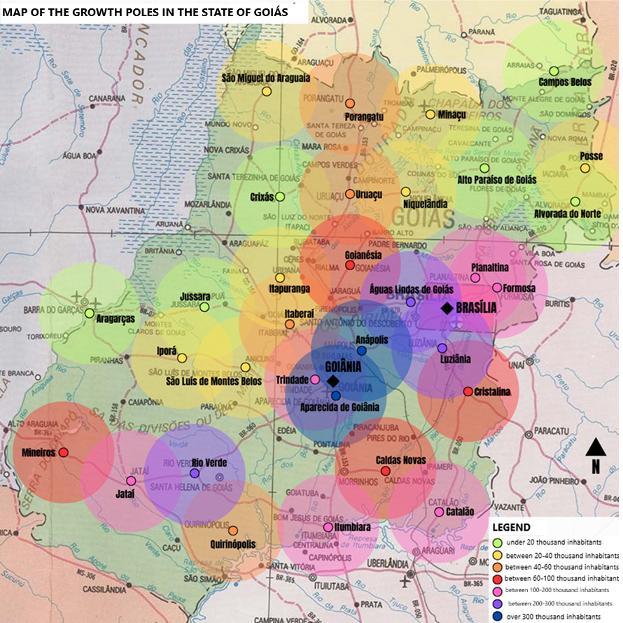 Source: Base map taken from IBGE (1995), modified by the authors (2024).

Although the radius of influence shown on Map 1 is considered to be the same size for all the hubs, we understand that as the hub city adds more quality services, demanding better-qualified professionals, it will be able to serve a larger population. In this case, considering the same geographical conditions, there is a tendency for a city with 40,000 inhabitants to serve a larger area than one with less than 20,000 inhabitants, for example. The growth poles in Goiás can be defined by the centralizing actions listed in the table below, separated by the regions where they are located.

Table 1 - Distribution of hub cities in Goiás, grouped by region

|  |  |
| --- | --- |
| City / Population | Region |
| Alto Paraíso de Goiás (10.306); Alvorada do Norte (8.446); Campos Belos (18.108); Crixás (17.065); Minaçu (27.075); Niquelândia (34.964); Porangatu (44.317); Posse (34.914); São Miguel do Araguaia (21.900); Uruaçu (42.546) | North |
| Anápolis (398.869); Aparecida de Goiânia (527.796); Goianésia (73.707); Itaberaí (44.734); Trindade (142.431); | Center |
| Águas Lindas de Goiás (225.693); Cristalina (62.337); Formosa (115.901); Luziânia (209.129); Planaltina (105.031) | East |
| Aragarças (18.390); Iporá (35.684); Itapuranga (26.113); Jussara (19.620); São Luís de Montes Belos (33.852) | West |
| Caldas Novas (98.622); Catalão (114.427); Itumbiara (107.970); | South |
| Quirinópolis (48.447); Rio Verde (225.696); Mineiros (70.081); Jataí (105.729) | Southwest |

Source: Prepared by the authors, with information from IBGE (2022).

Through the distribution of cities into populations and regions inherent to them, we can see some specificities of the geographical locations where they are located, such as those located in the north and west of Goiás, where we see, a population drain compared to the rest of the poles distributed in the state context. Another question we can ask is the number of hubs characterized as “small cities”, according to the IBGE, where of the 32 cities considered regional hubs, 21 are small, which gives the character of a network of small cities that help other smaller or similar ones, given their geographical privileges, due to their location in the middle of the road network, distribution of services, income, leisure, and tourism.

The definition of a small city depends on the objectives of specialists and specific public policies. According to Motta and Mata (2009), demographic size has been the most widely applied criterion for identifying small cities, which can be those with a population of up to 100,000 inhabitants. In addition, Santos (1979) considers that demographic capacity should not be the determining analytical dimension, because by considering a minimum population, as the United Nations (UN) guides, to characterize the different types of cities, we incur the error of a dangerous and fruitless generalization to think of alternatives to unequal development. Endlich (2006) complements this argument by stating that the characterization and categorization of different human settlements is a comparative task of relational attributes (political, economic, geographical, and social). Thus, it is also necessary to consider the elements and variables of each city, since the dimensions and attributes that may be adequate to characterize a small city in one region of the country are insufficient or inadequate in the socio-cultural context of another region.

From the above, it can be concluded that there is a dialectical movement between forces of concentration and dispersion in the territory. This idea, defended by Santos (1979), who identifies and characterizes small towns as “local towns”, contributes to understanding how these towns benefit from the dispersed allocation of natural resources and industrial production, directly influenced by the widespread diffusion of consumption and information. For the author, the term “local cities” can be a more operational concept than the notion of small cities, as he believes that the city should not be based on its population size, which would cause theoretical confusion. In his words, the local city is the “minimum size at which agglomerations cease to serve the needs of primary activity and instead serve the unavoidable needs of the population” (Santos, 1979, p. 71).

**4 THE EFFECT OF POLARIZATION IN THE SOUTHERN REGION OF GOIÁS**

In order to highlight the main growth poles in Goiás, we tried to delve deeper into some of the regions of influence of the selected poles. After some discussions and in-depth research into the history, economy, and geography of some of the hubs, the southern region of Goiás was chosen, as we felt it was a region with rising growth and would provide us with interesting discussions. The pole cities of Caldas Novas, Catalão, and Itumbiara are part of this selection, with demographic populations that match their size. In addition to the criteria presented above, the table of cities that offer the National High School Exam (ENEM) was also used as a definition, as the exam is not administered in all municipalities in Goiás. Thus, those where it is possible to take the exam are regional urban centralities. So, even though these cities are considered small, they strongly polarize the territories where they are located, acting essentially as growth poles, offering specialized services to regions of political and economic influence.

Map 2 - Catalão growth pole and its region of influence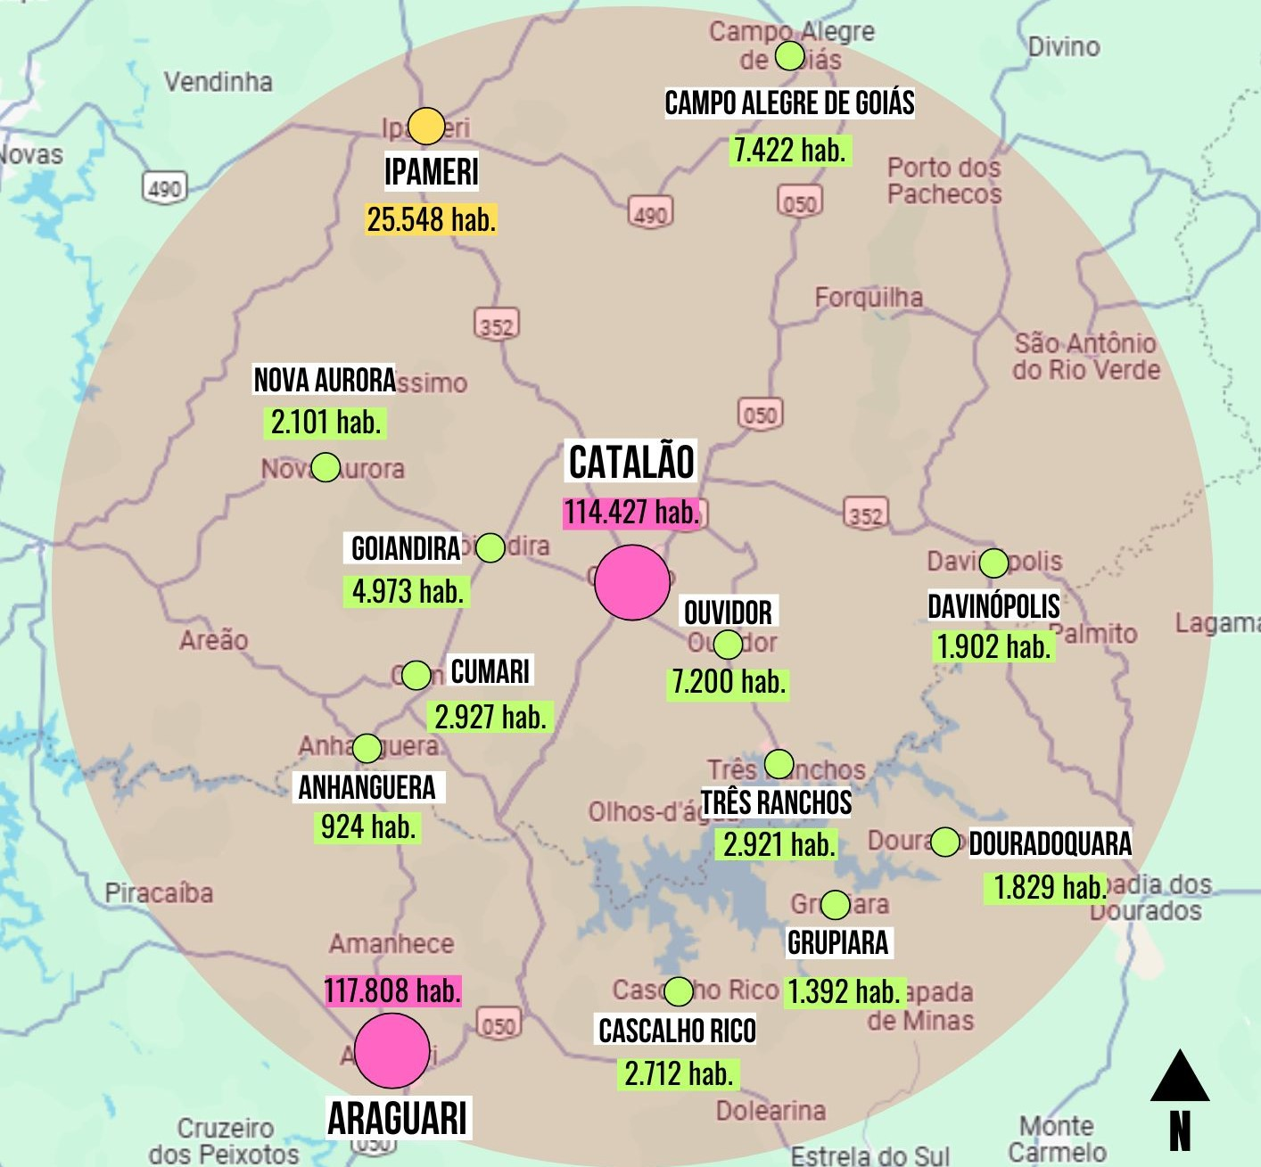

Source: Base map taken from the Google Maps platform (2024), modified by the authors (2024).

Map 2 shows that the Catalão growth pole is surrounded by a network of 13 cities. Among these, Araguari occupies a complementary position in the territory, as it is similar in size and demographics to Catalão, although they have different economic vocations. While Araguari's development was supported by the railroad (which runs as far as Ipameri), Catalão remains outside the railroad circuit, turning its economy towards the industrial and mining sectors.

The other small cities, except for Ipameri, have fewer than 10,000 inhabitants, which further consolidates and distributes the polarization between Catalão and Araguari. It's interesting to note that Ipameri and Nova Aurora are in the context of two growth poles, towards both Caldas Novas (map 3) and Catalão (map 2).

Map 3 - Caldas Novas growth pole and its region of influence

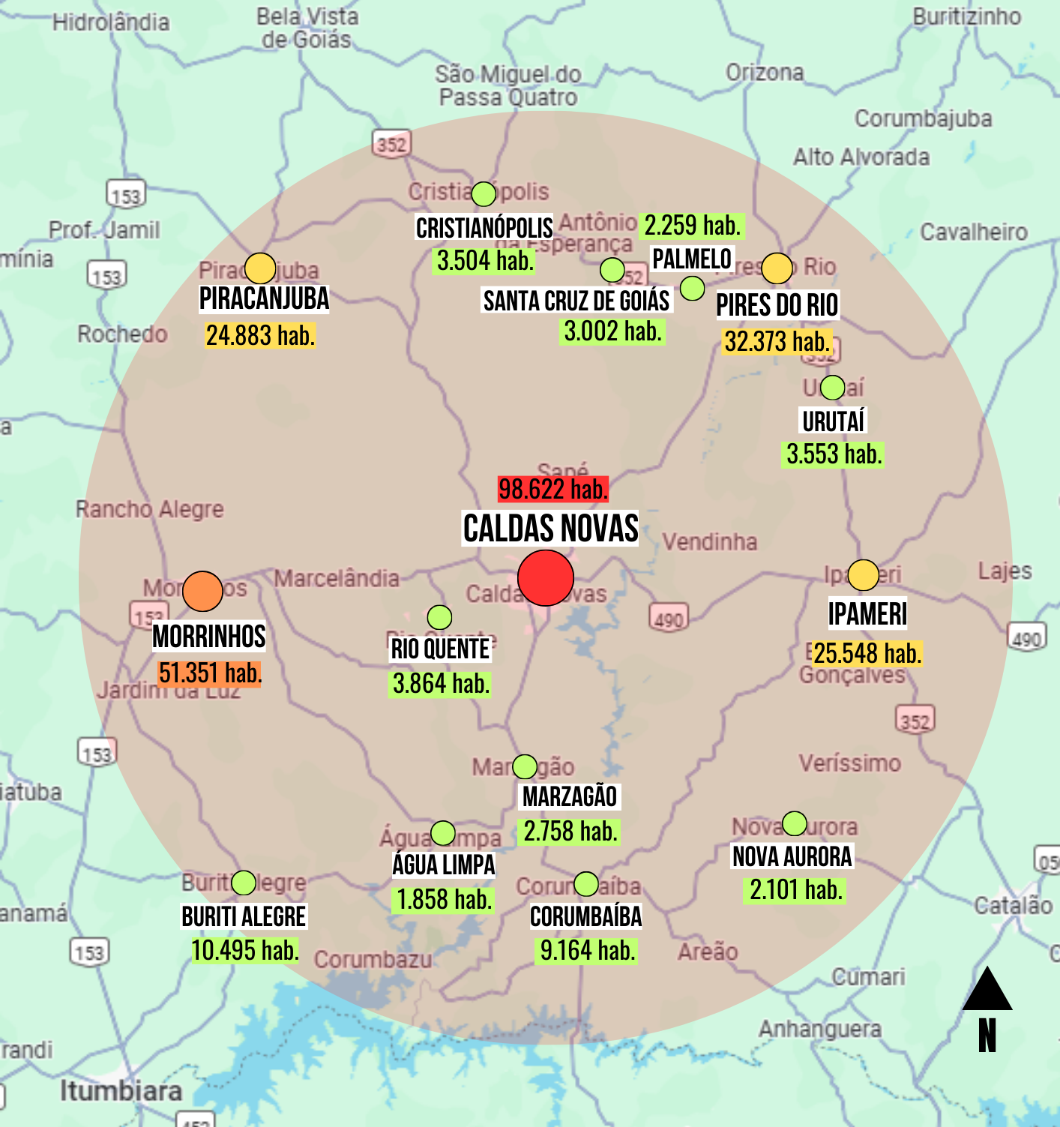

Source: Base map taken from the Google Maps platform (2024), modified by the authors (2024).

As a result of the incentives given to the tourist industry, Caldas Novas has witnessed a significant increase in its population, which in 1970 numbered 7,200 inhabitants; in the year 2000, it had 49,692 inhabitants; and in 2022, this figure had risen to 98,622 inhabitants. This sharp growth, in less than sixty years, can be explained by the migration of workers in search of opportunities in the large real estate developments, the resorts, clubs and water parks, the restaurants and fast-food outlets that keep springing up in the city center, and commerce in general. It's important to mention the displacement of businesspeople and specialized professionals from other regions of the country who come to the city for the growing investment in real estate, as described by Albuquerque (1996) and Belisário (2006).

As Map 3 shows, Caldas Novas is the central hub of a network of influences made up of 14 small towns located within a radius of 80 km from the hub. Of these, ten have fewer than 20,000 inhabitants. It can be seen in this context that Caldas Novas functions as a city-region, due to the work opportunities, services, and leisure options that it polarizes, with many people from neighboring cities making use of commuting daily. According to Santos (2005), the city-region can be defined by its urbanization process, with integrated elements through the increased flow of people, inputs, goods, and information, in a centripetal way in the territory.

Map 4 - Itumbiara growth pole and its region of influence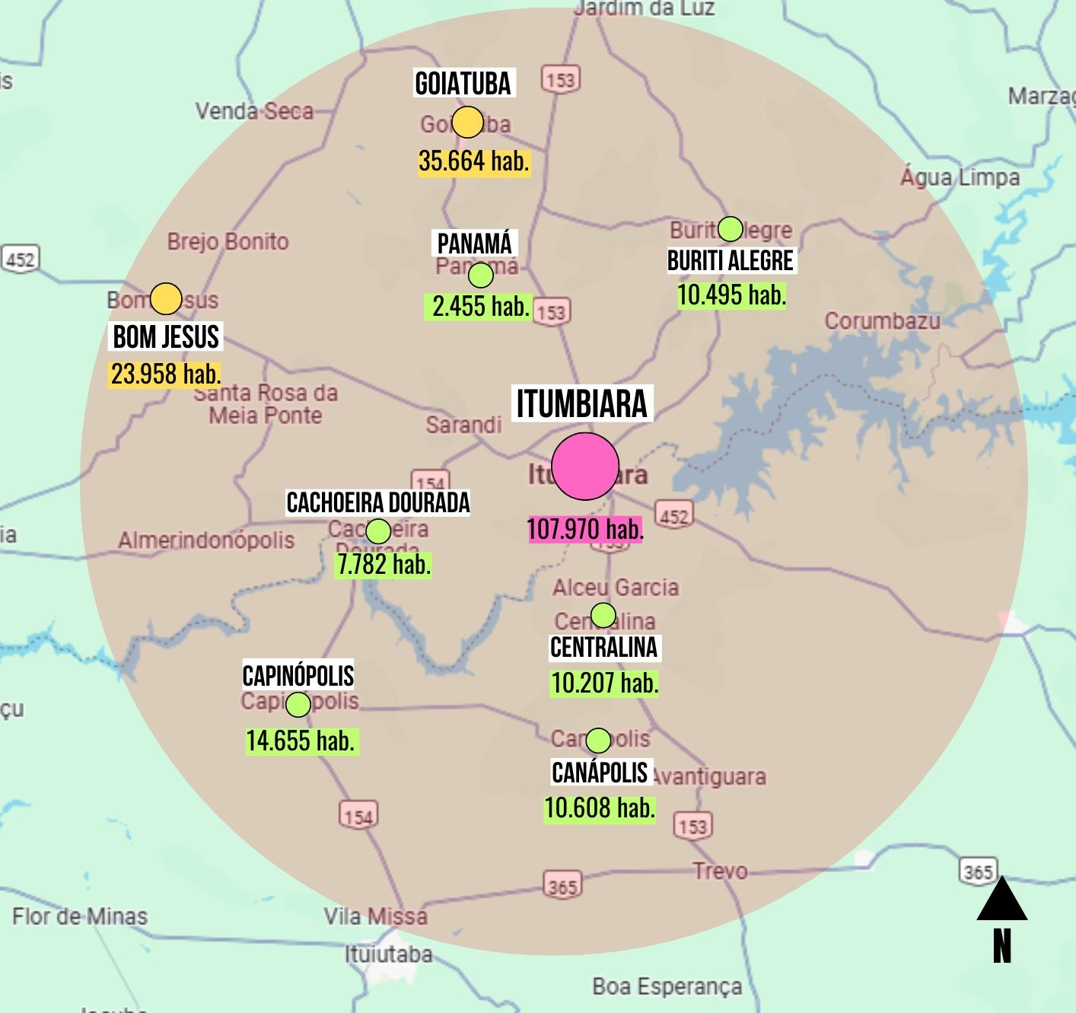

Source: Base map taken from the Google Maps platform (2024), modified by the authors (2024).

The Itumbiara hub (map 4) comprises 8 towns. Of these, two have between 20 and 40 thousand inhabitants, Goiatuba and Bom Jesus. The others are spread out, due to their geographical conditions, mainly influenced by the presence of the Paranaíba River, which also demarcates the border between Goiás and Minas Gerais.

According to Bezerra (2017), Patrick Geddes was at the forefront of using the term city-region, coining it at the beginning of the 20th century when he studied London and its role in the constitution of a region made up of towns, consolidated urban centers, and industrial centers. The cities he analyzed revealed the existence of a traditional consolidated urban center, which expanded radially towards its hinterland, on the edge of rural areas. Bezerra (2017) complements the discussion by stating that city-regions constitute ruptures and continuities in the process of formation of the cities and regions themselves, safeguarding the individual reality of each territory and that “to capture the meaning of these, it is necessary to better understand the nature of this phenomenon” (p.163).

It is therefore assumed that the city-region can take on a series of characterizations that distinguish it from the conurbed metropolis that gives rise to the metropolitan region. The city-region encompasses urban networks of different sizes and aspects, depending on their contexts and influences, as is the case with the city of Caldas Novas.

In his approach to space as a terrain for political practices, Michel Foucault (2008) analyses power based on strategies for understanding and organizing space throughout Western history, conceiving territory as a geographical notion, but even before that, a legal-political one. Therefore, “the creation and organization of space is not merely a passive process, since it relates directly to economic forces, but rather an object of power relations” (Freitas; Fiche, 2014, p. 102). Foucault (2013) argues that “allocation replaces extension, which in turn replaces location” (p. 114), which is somewhat similar to the study undertaken here through the growth poles, where allocation and its neighborhood relations say more about the territory than the positioning and size of the city itself, that is, that urban nucleus comes to be seen by its proximity to other neighboring cities or geographical elements, natural or not: roads, streams, mountains, etc. Simmel (1973) considered that the horizon of the modern city expanded in proportion to how the capacity to produce wealth developed.

Although the problem of allocation is presented in territorial studies in demographic terms (Foucault, 2013), it is broader: it consists of

to know which relations of neighborhood, which type of storage, circulation, identification, classification [...] should preferably be adopted, in this or that situation, to achieve this or that end: *we are in a time when space presents itself to us in the form of relations between allocations* (Foucault, 2013, p. 114).

Foucault (2013) analyses how spaces reflect a hierarchical organization of the allocation of things, places and ideas in the territory, referring to the work of Gaston Bachelard, who considers that we do not live in an empty, homogeneous space in which individuals and things are allocated, but rather in a tangle of qualities, meanings and relationships (Freitas; Fiche, 2014). Regarding urban planning, the configuration of cities is not only related to the “relationship between the capital and the rest of the territory, but also to the internal details of these interconnected urban centers, which should not be based solely on symmetrical figures, since they are functionally dependent on certain asymmetries” (Freitas; Fiche, 2014, p. 95), in other words, the territory succumbs to an organization that justifies an analysis from the macro to the microcosm, since there are relationships between small and medium-sized cities that go beyond relations with the metropolises.

**5 CONCLUSIONS**

The mapping of the growth poles in the regional context of Goiás shows a heterogeneous political and territorial framework, which cannot be established based on single criteria. Thus, the contribution of this work to urban studies is made to the extent that new agents of political influence in the territory are listed, considering the singularities of the social, geographical, and economic contexts. Highlighting the centralities that emerge from a network of regional influences goes beyond trade and the flow of people between cities, whether small, medium, or large. We therefore agree with Arrais (2008) in arguing that sets of interurban networks are structured outside metropolitan regions, constituting territorial complexes with specific proximity and segregation variables.

The theory of growth poles is an analytical strategy for urban conditions resulting from the influence of interurban networks in small towns, especially in the processes of urban expansion, the formation of centralities, and socio-spatial segregation. As Silva, Rippel, and Lima (2000) state, despite the criticism of this theory, some regional development policies, especially in the Northeast, Southeast, and South of Brazil, were built on its conceptual foundations, promoting a polarized development model from the 1960s onwards.

Understanding the dynamics of urban and territorial development, linked to the urban conditions of urban networks (which influence socio-spatial formations known as city-regions) points to new ways of thinking about small towns, from which opportunities emerge for multidimensional urban analysis: the role of urban form in structuring intra-urban and inter-urban socio-economic flows; the influences of city location on the economic, political and cultural transformations of city-regions; and the urban development policies undertaken by the various local and regional agents in these territories. A more in-depth study, on a closer geographical scale, of each of the hubs listed in the mapping carried out in this research could generate various reflections and numerous hypotheses on the question of geographical and demographic layout in the territory.

It is therefore important to point out that the current urbanization process has several polarized units in its territory, with interpolations between centralities with different socio-spatial influences. Finally, on a need to understand the political-administrative connections between the hub cities, when it is necessary to consider the not always democratic relations between social practices and territories, paying particular attention to the urbanization process. Based on this assumption, we can understand the differences and mismatches between the process of the constitution of a given territory and the relative political importance of the cities.

**6 BIBLIOGRAPHIC REFERENCE**

ALBUQUERQUE, Carlos. **Caldas Novas**: Além das Águas Quentes. Caldas Novas: Kelps Publishing, 1996.

ARRAIS, Tadeu Alencar. A cidade e a região/a cidade-região: reconhecer processos, construir políticas. **Cadernos Metrópole**. São Paulo, n.20, 2012.

BELISÁRIO, Alessandro Magno Damasceno. Fronteiras, frente pioneira e atividade turística em Caldas Novas - GO. **Caminhos de Geografia**. Uberlândia, v.7, n.17, 2006. p.123-128.

BENKO, Georges. **Economia Espaço e Globalização na aurora do século XXI**. São Paulo: Hucitec Publishing, 1996.

BEZERRA, Josué Alencar. A cidade-região sob as coexistências do território. **Boletim Goiano de Geografia**. Goiânia, v.37, n.2, 2017.

BRASIL. Brazilian Institute of Geography and Statistics (IBGE). **Censo Demográfico**. 2022. Available at: https://www.ibge.gov.br/estatisticas/sociais/trabalho/22827-censo-demografico-2022.html. Accessed at: 23 oct. 2023.

ENDLICH, Ângela Maria. **Pensando os papéis e significados das pequenas cidades do Noroeste do Paraná**. Thesis (Doctorate in Geography). Presidente Prudente: Universidade Estadual Paulista, 2006.

FOUCAULT, Michel. De espaços outros; tradução Ana Cristina Arantes Nasser. In: **Estudos Avançados 27**, v. 79, 2013. p. 113-122.

FOUCAULT, Michel. Sobre a geografia. **Microfísica do Poder**. Rio de Janeiro: Graal, 2008.

FREITAS, Lorena Martoni de; FICHE, Gustavo de Lucas. Arquiteturas do poder: contribuições do pensamento de Michel Foucault ao estudo do direito urbanístico. **Revista do CAAP**. Belo Horizonte, n. 1, v. XX, 2014, p.89-105.

GARCIA, Guilherme Henrique da Silva Basco. **Michel Foucault**: das cartografias do poder aos espaços outros. Dissertation (Master’s in Philosophy). Londrina: State University of Londrina, 2021.

HAESBAERT, Rogério. **Territórios alternativos**. São Paulo: Contexto, 2002.

HARVEY, David. **A produção capitalista do espaço**. São Paulo: Annablume, 2005.

IBGE. Geography Coordination. **Regiões de influência das cidades**: 2018. Rio de Janeiro: IBGE, 2020.

JESUS, Josias Alves de; SPINOLA, Noelio Dantaslé. Seis décadas da teoria dos polos de crescimento: revisitando Perroux. **Revista de Desenvolvimento Econômico**. Salvador, ano XVII, n.2, 2015. p.935-952.

LASUÉN, José Ramón. **Ensayos sobre economia regional y urbana**. Barcelona: Ariel, 1976.

LIPIETZ, Alain. **O capital e seu espaço**. São Paulo: Nobel, 1988.

MAGALHÃES, Felipe Nunes. Da Metrópole à Cidade-Região: na Direção de um Novo Arranjo Espacial Metropolitano? **Revista Brasileira de Estudos Urbanos e Regionais**, v. 10, n. 2, 2008.

MATTE JÚNIOR, Alexandre Aloys; ALVES, Darlã de. A Teoria dos Polos de Crescimento de Perroux: Uma Revisão Sistemática. **Revista de Administração e Negócios da Amazônia**, v. 9, n. 3, may./aug., 2017.

MOTTA, Diana; MATA, Daniel da. A importância da cidade média. **Revista Desafios do Desenvolvimento**, Instituto de Pesquisa Econômica Aplicada. Rio de Janeiro, ano 6, ed. 47, 2009.

PERROUX, François. **Ensaio sobre a filosofia do novo desenvolvimento**. Lisbon: Calouste Gulbenkian Publishing, 1981.

PERROUX, François. **L’Économie du XXeme Siècle**. Paris, Presses Universitaires de France, 1961.

RICHARDSON, Harry W. **Economia Regional**: Teoria da localização, estrutura urbana e crescimento regional. Rio de Janeiro: Zahar, 1975.

RIPPEL, Ricardo; LIMA, Jandir Ferrera de. Polos de crescimento econômico: notas sobre o caso do estado do Paraná. **REDES**, Santa Cruz do Sul, v. 14, n. 1, p. 136 - 149, jan./abr. 2009.

SANDRETTO, René. François Perroux, a precursor of the current analyses of power. **The Journal of World Economic Review**, 2009, 5 (1), pp. 57-68.

SANTOS, Milton. **A urbanização brasileira**. 5th edition. São Paulo: University of São Paulo Press, 2005.

SANTOS, Milton. **Economia Espacial**: Críticas e Alternativas. 2nd edition. 2nd reprint. São Paulo: University of São Paulo Press, 2011.

SANTOS, Milton. **Espaço e sociedade**: ensaios. Petrópolis: Vozes, 1979. p. 69-75.

SANTOS, Milton. **Técnica, espaço, tempo**: globalização e meio técnico-científico. 5th. São Paulo: Edusp, 2008.

SCOTT, Allen; AGNEW, John; SOJA, Edward; STORPER, Michael. Cidades-Regiões Globais. **Espaço & Debates**, n. 41, 2001.

SILVA, Andresa Lourenço da. Breve discussão sobre o conceito de cidade média. **Geoingá**: Revista do Programa de Pós-Graduação em Geografia. Maringá: v. 5, n. 1, 2013, p. 58-76.

SILVA, Josemar Raimundo da; RIPPEL, Ricardo; LIMA, Jandir Ferrera de. A teoria dos polos de crescimento de François Perroux. **Revista Cadernos de Economia**, v. 4, n. 7, 2000, p. 75-96.

SIMMEL, Georg. A metrópole e a vida mental; tradução Sérgio Marques dos Reis. In: VELHO, Otávio Guilherme (edt.). **O Fenômeno Urbano**. 2nd edition. Rio de Janeiro: Zahar Editors, 1973. p. 10-24.